MANUSCRIPT
Collaborative Filtering and Personal Identity: A Conversation on the Artificial-Intelligences of Streaming Platforms
By Benjamin Micallef

Abstract:
Collaborative Filtering is an algorithm application which predicts the tastes and desires of consumers. Often presented as “Recommended for you” and “Discover weekly” on streaming platforms— collaborative filtering is a highly utilized tool streaming platforms use to dictate their consumer’s aesthetic engagements. This highly effective technology provides social theory and philosophy with a situation of ambiguity due to its fast-paced public delivery and covert methods. To help accurately diagnose the motivations of an A.I metric-driven Western entertainment industry, this paper researches and analyzes some of the hidden infrastructures of streaming platforms' use of collaborative filtering. This paper hopes to introduce some concepts in Critical Theory in order to analyze how these types of algorithms of decision making affect personal identity.

Introduction
As the entertainment industry continues to utilize and rely on emerging technologies that push the bounds of the means of taste-distribution, the digital ethicality of its approach should be questioned. Today the entertainment industry follows a technological-positive implementation of supposedly objective approaches (math-based, artificially-intelligent) to subjective situations (aesthetic, experiential). This approach to culture according to its reception is positive and apolitical because it promotes the consumption of more material rather than bearing any certain external bias on what entertainment should be consumed. Since the advent of highly effective Collaborative Filtering algorithms, in 2006, consumers have been able to better discover aesthetics similar to their tastes faster and seemingly more explainably than ever before. This convenience has permitted diverse and broad tastes to be possible to all consumers of the entertainment industry. Whether it be music, film, literature or other aesthetic dimensions, the monthly buy-ins to access these digital streaming platforms with AI-based recommendations are at the price of a meal.
However unlike food and other major industries, the commodities of the entertainment industry already possess enough reusable material to last lifetimes. This deems the entertainment industry an industry of unnecessary production. If all of its production suddenly stopped, the well-being of society from a physical or mental health standpoint would not be instantly affected. So it can be said that the mass circulation of new entertainment does not tangibly promote society. For this reason, instead of society being reliant on the industry (food, materials, energy), the industry is reliant on society. This is a fundamental aspect to the economics of the entertainment industry. For the entertainment industry to continue, its products must be consumed and not recycled. Collaborative filtering promotes that.
In this paper I will show, based on socio-philosophical and anthropological aspects of collaborative filtering (in Netflix, Spotify, Youtube, and Tik Tok), how this approach for promoting cultural consumption promotes a more passive and less critically invested consumer. I will argue how this change is detrimental to personal identity and critical engagement, and that while it seems to support the current entertainment industry, this type of consumer is not viable for a long-term societal engagement with art. I will begin with a philosophical analysis on what it means to experience art, and why it is important. Following this, I will provide a detailed account of collaborative filtering and its functions through a critical analysis of different digital streaming platform applications, in order to uncover the unaccounted for costs of these progressions.

Experiencing Art and Aesthetics
An aesthetic is something or some things which concern or invoke a form of beauty. An aesthetic can be intentionally or unintentionally formed. Natural landscapes can be aesthetics and so can artworks. Aesthetics can be selections of similar objects and they can also be selections of dissimilar objects (such selection would form an aesthetic of unconformity).
There are a few important maxims I would like to present about aesthetics and the experience of them:
- They happen. The emotional effects of aesthetics are very tangible and potent.
This is evident in the fact that aesthetics have the ability to create experiences of the beautiful and the sublime.
- There is a way they happen. Similar to how emotions (experiences of the beautiful and the sublime) are the effects of aesthetics, aesthetics are the effects of cognitive categorizations.
I am defining cognitive categorizations as the signification of signs and symbols. In extrapolation, there is a causal order in the semiology of aesthetics: First there is materiality (physical objects), then it gets signified as a thing (into an aesthetic or type of aesthetic i.g., nature, industrial, synthetic), and this cognition results in an emotional response.
- There is an extent in which they do. We cannot prevent ourselves from cognizing materiality; however, we can decide to what extent we do.
Although everything can be considered an aesthetic, given that all things can be mentally categorized into fields of characteristics, i.e., the technical effort of carefully cognizing all phenomena into aesthetics— all the time; we simply do not do this. If we were to, we would not get anything done, and so it is best to pick our battles; we subconsciously know this.
- Finally, aesthetics are artificially constructed by people and society.
The things which we characterize as aesthetics are typically objects of individuality, pattern, and formation; they always exist uniquely. Individual objects that can be called aesthetic can be a single rose, juxtaposing colors, misplaced objects, absent objects, and relatively expensive or inexpensive objects. Patterns are objects which follow a sequence of repetitions consisting of a common design or a relationship of multiple repetitive designs. Aesthetics of formation are objects which particularly share commonalities with their surroundings, such as a bouquet of flowers. There are also aesthetics which are signified in relation to time. For instance, the place in which one parks their car at their living quarters is not often identified as a platform or destination of aesthetic flourishing. However, if one were to leave their town for a long period of time and then return, the action of entering the recognizable atmosphere would ignite a nostalgic feeling. This emotional response could signify the parking space as an aesthetic of nostalgia. This is a clear example of how we might dictate significations of aesthetics based on temporal familiarity.
Artworks, assemblages of classes of objects which form a coherent thing, are always aesthetics. However, as mentioned before, not all aesthetics are artworks. It is important to signify aesthetics and engage them. This is what the entertainment industry is: a series of platforms which signify aesthetics. This formulation of aesthetics is not at all compromising of all forms of aesthetics, but it is encompassing enough for the task at hand.

Art and Technology
It is impossible to experience aesthetics without technology, for the perception of aesthetics is always related to the perception of technology. There cannot be a play performed without a stage, and music cannot be played without instruments. In other words, ‘The aesthetic, grasped in its totality, is both the result and the project of the existing mode of production.’
Today, even experiencing the aesthetics of nature (an aesthetic seemingly without technology) invokes an emotional engagement which juxtaposes industrial and modern culture. Feeling of solitude and tranquility, often being the engaging emotions of nature’s aesthetic, is responsive to the state of modern industrialisation. For instance, the aesthetics of nature means something different to Thoreau than to a caveman. Even if a caveman-archetype were to experience nature, their lack of a notion of advanced technology would manipulate their aesthetic engagement. Art, however, is unlike the unconscious provocations of the mind.
Frankfurt School philosopher Herbert Marcuse argued that art has a transcendent capability. From stage to film, song to record, text to media— art in any form, he believed, has aspects which can subjugate its audience to a realm of cognitive autonomy. Unlike nature which has an emotional response contingent on the means of production, the experience of art has an undetermined response. Marcuse thought that the certain aesthetic engagement that people have with art allows people to contemplate under circumstances that are free from one’s existing situations. This is because art, for Marcuse, has an autonomous essence.
Movies, as an example, possess a semiotic capability which intrigues and gets the audience attached to its narrative. People cry, laugh, and invest in film narratives even though they are usually fictional stories. Films can be paused, returned to, and rewatched over and over again, and because this is so, it seems strange that movies are observed so attentively.
This attentiveness is due to the fact that film viewers recognize the aesthetic form of film. The aesthetic form is the form in which art presents itself. Technically speaking, the aesthetic form is identified by the normative technologies art genres consist of: frames, gallaries, paint, paper, sculpture, film projections, sound, patterned movement, and etc. When I see something occur and it is taking place on a two-dimensional rectangular screen, I can be sure that the happening is not real life, it is cinema. While this seems obvious, aesthetic form has historically been difficult to identify to the general public. In fact, the first movie ever, L'Arrivée d'un train en gare de La Ciotat (1895) by the Lumière brothers, notably “had a particularly lasting impact [on its audiences]; yes, it caused fear, terror, even panic.” Viewers at the turn of the century when watching a train arrive at a station, projected in black and white, actually ran out of the room, screaming, thinking that they were about to get hit by a real train. This illusion sounds ridiculous now, but it is actually very similar to the ways we treat our present platforms of aesthetic engagement. Eventually, this retrospective example will not seem so different to the illusory associations we make of the aesthetics of entertainment with our personal expressivity and thus our personal identities such as quoting Vines, or adopting gestures from TikTok.
Returning to the point, art, Marcuse wrote, “...transcends its social determination and emancipates itself from the given universe of discourse and behaviour while preserving its overwhelming presence [i.e. aesthetic form]. Thereby art creates the realm in which the subversion of experience proper to art becomes possible: the world formed by art is recognized as a reality which is suppressed and distorted in the given reality.” Therefore it can be said again that in art, when the audience consumes its aesthetic, the audience is placed into a materiality which is autonomous from the reality they presently exist in. The film is not real, but the message is true. Prospero does not suffer from his own power (he is text on a page), but we feel that he does. Whether it be tragedy or comedy, “society remains present in the autonomous realm of art”. As society's aesthetic interaction is this way, arts materiality contains a radical political potential because art can transport and transcend its audience to a sphere of discourse which is entirely alien from reality. In this way, dialectical thinking can occur.
Dialectical thinking through aesthetic engagement is not an exclusive ability only available to philosophers. Dialectical thinking is a form of contemplation which requires criticism and debate within the process of understanding. Art as it utilizes controversial subjective materiality engages its audience into an unclear and thoughtful process of interpreting. Art's subjective nature allows for dialect. So, when engaging with the aesthetic and one is only given the reality that exists within the artwork, the audience adopts its sphere of discourse in order to interpret it.
Returning to film as our seminal example, there is nothing at stake for the audience watching. The train is not going to hit them, and so, horror becomes excitement, and suspense becomes interest; the audience begins to participate in art. In modern philosophy, this captivating capability has been defined as play. Similar to dialectical thinking, play is another social relationship viewers have with art when they aesthetically accept art’s discourse.
Play is a discursive, dialogical, intervention with art. It is a type of communicative practice which the audience can have with art which puts them into it, not as a reflective judgement from Kant’s non-purposive attitude of aesthetic theory which the Frankfurt School utilized, but rather a convention of play which promotes the audience as an emotional force at stake with the art. Think of listening to a song with headphones on, turning up the music, and pretending that the song's context applies to you and is actively being created by you. That, I Just Wasn’t Made For These Times was about your current times, not Brian Wilson's 1966, or that the backing to Tamla’s (Motown’s) studio hits were a instrumentation composed of your internal circumstance, and not the experimental recording techniques of The Funk Brothers which was produced to correspond to the needs of the time’s Detroit-based pop music industry.
Dialectical thinking and play are two of many relationships art’s autonomous dimensionality permits. Art has aesthetics within it and they are the work’s normative physics, landscapes for contemplation. There are cognitive responses to the captivating; Play is to pretend that the artwork is real, to entertain an autonomy in it; and dialectical thinking is a discursive, rigorous process of discerning reason in the artwork’s sphere of discourse. Aesthetic components in art, when art is convincing, are variable-like entities which are waiting to be deciphered, and they are terminally reliant on the state of technology.

Technology as Infrastructure

In anthropology, infrastructure studies is the study of the organizational structures and facilities which are used by states and groups of people. The linguistic roots of infrastructure is: infra- which means below, and -structura, derived from structus, the past participle of struere, the latin verb ‘to build’. An infrastructure is essentially an apparatus which builds from below. In this section I am going to introduce infrastructure studies as a lens to analyse technology.
Roadways and public planning are poignant examples of a type of infrastructure which at a very basic level (literally surface level) builds and organizes society. We are so accustomed to this infrastructure that often when we are driving, an incredibly complicated and dangerous task, we subconsciously navigate it. Think of this: highways are usually long and wide, and because of this highways make driving at higher speeds safer; highways are built to be safe. Now, remember when you were learning how to drive and you only drove on neighborhood streets. At this time, driving on the highway compared to neighborhood streets was not only difficult, it was scary and dangerous for you, and the other people on the highway. Although you were a safe driver at 25 miles per hour, at 65 miles per hour you were dangerous. This was not because you were bad at driving in general, it was because you were not used to driving on highways as an infrastructure. Being good at driving on highways, namely California highways, is not a historical constitution to being considered a good driver. In fact, there are countless people in the world today who are functional drivers but cannot drive on modern highways. In order to drive on highways you need to adapt through practice. In other words, you needed to manufacture yourself in accordance with the infrastructure. Infrastructures are man made, artificial, constructions for navigation.
Building infrastructures come with predictions. When building an infrastructure, there is always an assumption of what needs to be streamlined and made more efficient. Roads are built because it is predicted that people have to get around. Scissors are made because things will need to be cut. When these predictions are made and infrastructures are built there are things that are accomplished— but this is not always the case, sometimes infrastructures fail and break down. In today's time, living in California, society lives towards the brink of infrastructural collapse often. From 2010 to 2014, California was unable to provide water to its own people due to a lack of infrastructure (water storage and distribution). Just recently, our state energy infrastructure collapsed due to the corporate neglect of infrastructural maintenance. Today, as we are moving closer and closer to the edge of a public health infrastructure collapse, due to COVID-19, citizens are adopting utensil-type infrastructures, such as facemasks, in order to combat disease. As you can see, infrastructures range from vast systems to small objects which we use as tools to extend our abilities to navigate ourselves within the world.
However, there is not a binary, pass or fail, result to infrastructure implementation. Infrastructures can often complicate our interactions as a cost of benefiting others. Roadways promote the pollution of greenhouse gases, and cars infinitely heighten the existential risk of moving from place to place. The reason that these negative complications co-exist with the benefits of infrastructures is because society believes that the good effects outweigh the bad, and because this is so, the existence of infrastructure can be seen as a societal signifier of values. Today, in the case of modern sanitary infrastructures, the value of public health outweighs the values of reusability and the avoidance of using highly condensed and toxic chemicals on our bodies. Our uses of infrastructures actively signify what we believe to be important (life over environment and skin-care). Even the deliberation of when to or when not to wear a facemask is an example signifying values through infrastructure. What we do when we implement facemasks is that we make value judgments on what air is safe and what air is not safe. We are mechanizing areas of space through a subjective radar of safe and not safe air. We are adjudicating air. Putting on a facemask is a symbolic act to signify that the air has moved from the background, safe, into the foreground, risky.
Karl Marx called the act of implementing sense by the use of external objects, manufactured senses. Manufactured senses as a concept first appeared in Marx’s Economic and Philosophic Manuscripts of 1844. In it he writes,
But just as nature provides labor with [the] means of life in the sense that labor cannot live without objects on which to operate, on the other hand, it also provides the means of life in the more restricted sense, i.e., the means for the physical subsistence of the worker himself.
Thus the more the worker by his labor appropriates the external world, sensuous nature, the more he deprives himself of means of life in two respects: first, in that the sensuous external world more and more ceases to be an object belonging to his labor – to be his labor’s means of life; and, second, in that it more and more ceases to be means of life in the immediate sense, means for the physical subsistence of the worker.
In both respects, therefore, the worker becomes a servant of his object, first, in that he receives an object of labor, i.e., in that he receives work, and, secondly, in that he receives means of subsistence. This enables him to exist, first as a worker; and second, as a physical subject. The height of this servitude is that it is only as a worker that he can maintain himself as a physical subject and that it is only as a physical subject that he is a worker.

Here Marx is speaking about factory labor. As workers continue to labor in factories and use tools and machines to manufacture products, Marx argues that workers begin to simulate themselves to the physical objects they are using. For example, if someone's sole task on an assembly line is to hammer in a certain nail, and this is all that they do, eventually the worker will mentally associate the hammer they have in their hand as a part of themselves. They manufacture the sense of the hammer to be a part of their natural senses. This is similar to the highway infrastructure situation. When we want to go to a location, we naturally move ourselves into that direction by using the means which surround us. At a basic practical level, we walk to the place. When we have a car and a highway to compliment it, we use it to get where we are trying to go. We don’t insist on operating the machinery of a car, however when it is available we will. Operating a car is not for the sake of operating it, instead it is a means to getting to where we want to go. So, we are not exactly partaking in the joy of driving, the activity is merely a tool to do what we want to do. So insofar as infrastructure continues to build and organize society by the means of its technologies, we respond by beginning to mesh and interrelate ourselves with infrastructures, and it is not our choice.
The way in which we adapt ourselves to infrastructure is the same way we adapt ourselves to art (as explained in the previous section). Art is an infrastructure, a technology of emotional provocation which we assimilate with in order to expand ourselves as emotional beings. As said before, we do not consciously allow art to affect us, it just does. We do not choose that highways exist, they just do. And so, by living in modern society we are inevitably affected by infrastructures. Collaborative filtering, the artificially intelligent algorithm which directs us to new art, is an infrastructure which organizes us when we interact with the aesthetic realm, a realm incredibly important to who we are. In the next sections I will explain this algorithmic infrastructure and its repercussions.
- Collaborative Filtering
Collaborative filtering is a type of algorithm. Generally speaking, an algorithm is a typed out set of instructions or a roadmap that tells a computer what to do or how to utilize a sum of data. When you are typing a search into Google, per say, and before you finish typing there already appears recommendations as to what you might be looking for, that is an algorithm. In fact, collaborative filtering is very similar to this google recommendation application because both algorithms utilize what is called Machine Learning. Machine Learning is a type of category or genre of algorithm which builds a mathematical model of data, known as training data, which builds upon its efficiency with the more data it comprehends. Here are the four different uses of machine learning algorithms:
1. Create content such as retrospective year-in-review videos on Facebook and, increasingly, through advanced ML libraries like OpenAI's GPT-2, or deepfakes
2. Manage flows through active recommendations and content caching as well as negative shadow bans that limit the appearances of certain messages on social media
3. Mediate interaction with information often through the array of signals, for example, likes and comments, that inform information flows and content discoverability
4. Rank and filter information in ways that create incentives and conditions of interaction similar to markets or system engineering that creators must learn and “game” to succeed online
A combination of categories 3 and 4 is the type of machine learning collaborative filtering exists in. Collaborative filtering is a code which specializes in the interests of the consumer through a ranking and filtering of information based on the consumers’ interactions with products. What makes collaborative filtering so interesting is that,— unlike category one which is for data summaries, chronologies, and mimicry; or two. which is for censoring material,— collaborative filtering is for inferring the taste of a consumer.
Taste as a transitive verb, ‘having taste’, came into linguistic popularity in the 14th century. In the European Middle Ages, when kingdoms and large societies of people began to congregate and social groups arose such as guilds, taste— deriving from the Anglo-French word taster, which was the tax man, a subjective businessman who would determine the tax payment by virtue of his taxare, the latin verb ‘to touch’ or ‘to feel’— became the word for the ability to navigate popular fashion. If you had the ability to assess the value of material things, like the tax man could with his fellow citizens, then you had taste. Having an adaptive taste, or in other words a manufactured sense on what to buy, is one of the most prized qualities of the modern day consumer. Collaborative filtering mediates consumer-to-commodity interaction with sums of information. This mediation is no less than the automation of adapting one's taste to the tastes of similar consumers and their commodities.
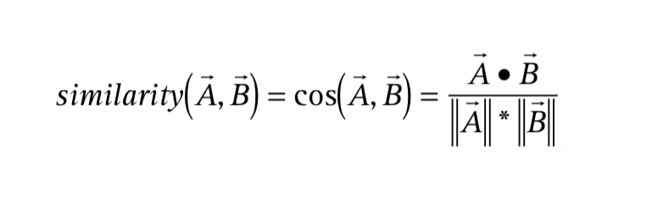
The first website to utilize collaborative filtering was Amazon. In order to match buyers with products similar to their buying histories, Amazon (in the early 2000s) utilized a very traditional model of collaborative filtering. The function looked like this:
The two variables in the function, ‘A’ and ‘B’, represent two different consumers. A consumer is identified as a sum of an account transaction history, and insofar as a consumer shares a portion of their transaction history with another consumer, then they are paired to be computed together. As an example, variable ‘A’ buys a Hemmingway and a Fitzgerald novel, while variable ‘B’ buys a Hemmingway and a Mark Twain novel. Based on sharing 50 percent of their transaction histories with each other, the algorithm then multiplies their sums as ‘vector components, by the inverse frequency,’ and makes less well known items known to the corresponding consumers. So, ‘A’ will get the Twain novel as a recommendation, while ‘B’ will get the Fitzgerald novel. This algorithm can take much larger sums of transaction histories and create deep catalogues of recommendations. However, this traditional model was limited in its scope. It could not account for similar buyers which did not share any identical purchases. For instance, if a consumer ‘C’ were to buy a T.S. Eliot and a Virgina Woolf novel, (deeming themselves very likely to buy Hemmingway, Twain, and Fitzgerald) this reader would not be paired with ‘A’ and ‘B’s histories.
In 2006, collaborative filtering evolved. On this year, Netflix released a data science competition in order to improve its recommendation algorithm. The competition was called ‘The Netflix Prize’ and the winner would go on to win $1,000,000 USD. The company provided a training data set of 100,480,507 movie ratings (1 to 5 stars) of 17,770 movies from 480,189 users. Each data point was organized as: < user, movie, date of grade, grade >. The minimum algorithm accuracy improvement which could earn the prize was 10 percent. Since this improvement was so hard for Netflix, they expected it to be a multi-year competition and incorporated an annual $50,000 bonus for the most improved competitor if their contribution increased the algorithm accuracy by a minimum of 1 percent. Two weeks after the competition was released, drama ensued when Arvind Narayanan, a PhD student at the University of Texas at Austin, and his advisor, Vitaly Shmatikov, were able to “attach real names to many of the ‘anonymized’ Netflix records.” In their research paper, they wrote:
“We demonstrate that an adversary who knows only a little bit about an individual subscriber can easily identify his or her record if it is present in the dataset, or, at the very least, identify a small set of records which include the subscriber’s record. The adversary’s background knowledge need not be precise, e.g., the dates may only be known to the adversary with a 14-day error, the ratings may be known only approximately, and some of the ratings and dates may even be completely wrong.”
This improvement was so astoundingly accurate that Netflix was sued by a closeted gay mother of two children. She claimed that Netflix’s ability to use her data and de-anonymize her interests in certain films “...would negatively affect her ability to pursue her livelihood and support her family, and would hinder her and her children’s ability to live peaceful lives.”
While the percentage increase which Narayanan and Shmatikov provided to Netflix was never quantified, it nonetheless dramatically improved the technologies of aesthetic recommendations. Today collaborative filtering has been able to achieve higher accuracies predicticting the tastes of consumers insofar as the consumer rates a product and it is tracked under these four criterions: < user, movie, date of grade, grade >. Every website of consumption can track this data. Whether it be social media likes, music saves, follows, or even playlists, the abilities Netflix and Amazon shows exist on all platforms of recommendation. For a visual example, here is an example of how multiple consumers can be graphed to determine the tastes of others.
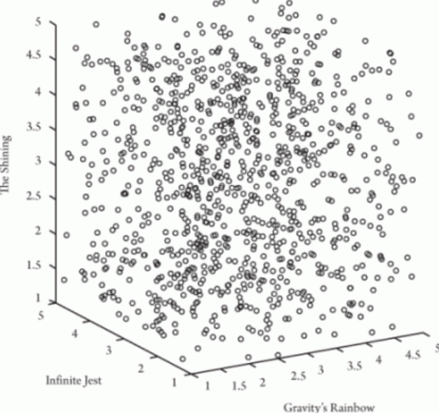
Instead of two consumers who have bought three different books, imagine one thousand consumers. Authors M. Kearns and A. Roth in their book The Ethical Algorithm provide the following graph in an incredible example of the expansive nature of collaborative filtering. The three books are: Thomas Pynchon’s Gravity’s Rainbow, David Foster Wallace’s Infinite Jest, and Stephen King’s The Shining. In this hypothetical example, one thousand consumers read and rank all three of these books on a sliding scale of 1 to 5. Each reader’s rankings is plotted on a three dimensional x,y,z axis graph (a scatter plot). A consumer who rates each of the books a certain rank, say 3 for Infinite Jest (x-axis), 4 for The Shining (y-axis), and 2 for Gravity’s Rainbow (z-axis), would have an axis point of (3, 4, 2). This coordinate would exist on the upper-left side of the graph:
With this information, it would be safe to say that the example consumer is a fan of the book The Shining, and furthermore, the reader enjoyed reading Infinite Jest more than Gravity’s Rainbow.
A relative variable is introduced in the ranking of the products. Now, if a person were to only read Gravity's Rainbow and give it a similar ranking of 4 to 5, then it could likely be the case that they also would also have the relative opinion that Infinite Jest is better than Gravity’s Rainbow, if they were to read the two. Now, imagine that this relative opinion did exist amongst many consumers, and on the contrary many consumers who like Gravity’s Rainbow had a more favorable opinion of Infinite Jest than The Shining. If these relative variabilities were to be plotted in groups, where fans of The Shining (circles) prefered Infinite Jest over Gravity's Rainbow and fans of Gravity’s Rainbow (triangles) prefered Infinite Jest over The Shining, the graph would look like this:
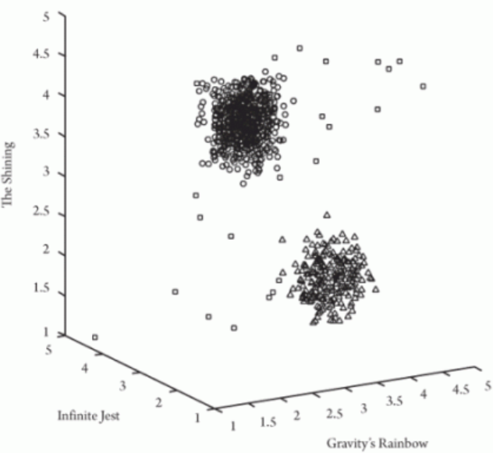
Fans of The Shining and fans of Gravity’s Rainbow graphically display a herd-like mentality of literary tastes. So, if a reader were to only read and rank one of the three books, the data set, without little error, would predict not only what to recommend, but also what not to recommend and explicitly limit the consumer from being exposed to books they are likely not to like. In the next section I will closely analyze similar modern applications of collaborative filtering.
  - Case Studies
This next section will present case studies of some notable platforms which utilize collaborative filtering. Each section will briefly describe how collaborative filtering exists on the platform and then closely analyse some certain aspects of its use which might be problematic.

Netflix
Today when Netflix opens, the consumer is immediately presented with a playing trailer of a TV show or a movie. Currently, my Netflix interface (April 22, 2020) shows me WACO, a show about “When federal authorities attempt to seize a religious compound, a standoff with its prophetic leader and his followers ensue. Based on true events”. It appears to be ranked #4 in the U.S today, and I do not know if this show was chosen specifically for me, but I do not mind because this show seems interesting to me. I enjoy shows which are dramatic, based on true events, and related to cults. The next selections of films on the interface are: “Popular on Netflix,” “Continue Watching for Ben”, “Trending Now”, “Watch it again”. “Top 10 in the U.S”, “Top picks for Ben”, “Critically Acclaimed Films”, and so on. It seems as though “Top picks for Ben” is where collaborative filtering lies. However, something intrigues me which also pertains to my personal taste. The cover images of the movies and TV shows intermittently change as I log in and out of my account. Specifically, the show Stranger Things’ cover image changes to different images of different characters in the show.
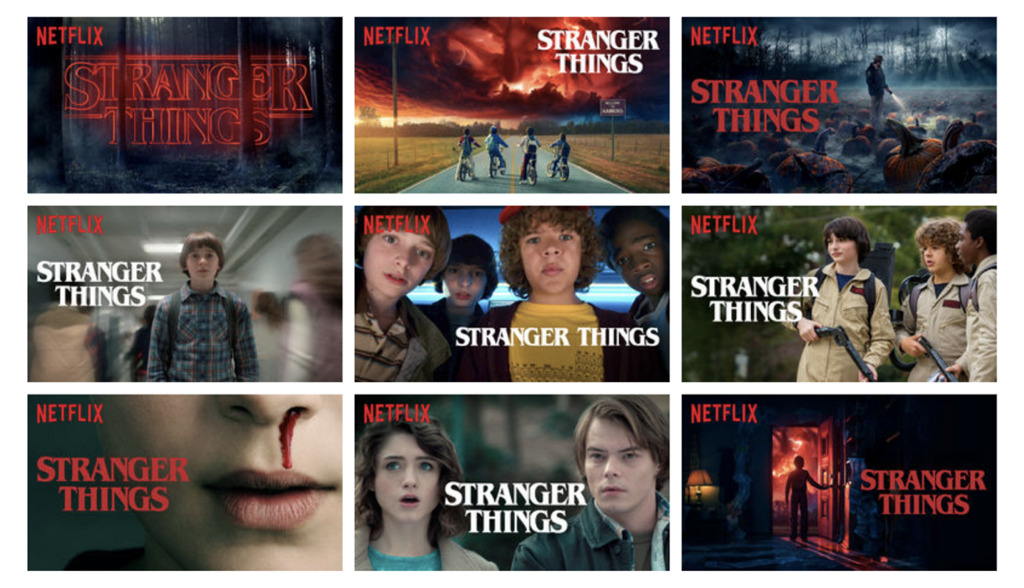
As it turns out, there is an answer to my observation. All shows on Netflix have twelve different cover images. Take Stranger Things as an example:
Each of the twelve images seem to tell a different story as to what the show might be about. While the top-middle cover seems to be an adventure, the bottom-left cover gives more of a horror film impression. The middle-right cover could be a comedy considering the actors are wearing ghostbusters costumes. A viewer who knows nothing about the show can get a multiplicity of different impressions based on the image they are given.
Netflix determines which cover images to show its consumers by using a machine learning algorithm called an A/B test. An A/B test tests different collaborative filtering algorithms on demographics of users in order to find out which algorithm produces the most effective cover image selections for said demographics. This algorithm matches algorithms with consumers in the same way the early collaborative filtering algorithm matches products with consumers.
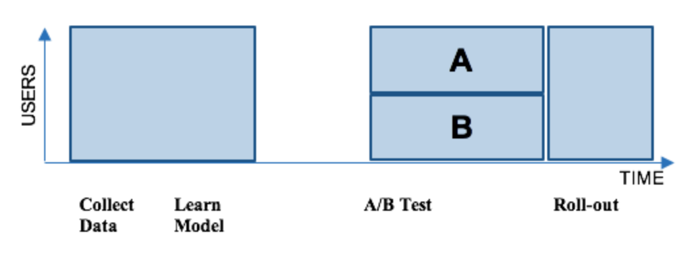
The process of an A/B test is as such: Netflix collects a sum of users of similar taste and divides the sum into two groups, A and B. Members of A are given one cover image for a film and members of B are given a different cover image for the same film. The two cover images are products of two different collaborative filtering algorithms which predict cover images that the consumer might find most aesthetically attractive. If all of consumers in a said test were to particularly like coming of age movies, then the one algorithm might produce bottom-middle image (from the example above) for group A, and the other algorithm might produce the center image for group B, as both display kids making curious and innocent gestures. Whichever algorithm has the most hits on the control variable film provides Netflix with the understanding that the certain cover images which came from either the A or B algorithm works best for the tested demographic. The better algorithm is then taken up by the system. Here is a visual of this code:

The problem which arises from this comparative machine learning algorithm is two-fold. Firstly, films can be presented in two completely different ways, thus potentially providing false information to consumers on what type of movie they might be clicking to watch. Secondly, this potential false information is determined by the customer’s viewing of the film, rather than the type of film it is in relation to their tastes. Basically, this machine learning algorithm provides the illusion of consumer enjoyment and does not take into account what the movie actually consists of.
Here is a visual example of how the movie Good Will Hunting is presented for someone who likes romance and for someone who likes comedy:
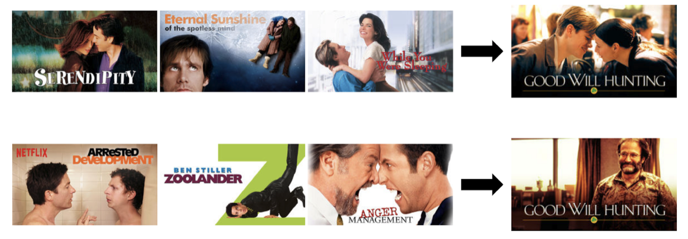
While both of the viewers with separate viewing histories might like Good Will Hunting, the intention of the algorithm was merely to expose them to it.
Collaborative filtering, as it pertains to Netflix, does not appear to hold the consumers viewing aspirations to the utmost importance. This algorithm utilizes the aesthetic to promote the ideology of a democratic infrastructure of art viewing. What the consumer is, is a means to an end. Netflix wants the consumer to see the content, on an objective level of quantification rather than a subjective level of sensual qualification. What appears to be the consumer's self, projected into selections of artworks, is actually the consumer being taken advantage of by the publicity of their data and their taste.
Spotify
Spotify is the most used paid music-streaming platform in the world. By introducing subscription based listening, the Swedish company surpassed iTunes’ monopoly of internet music listening. Since 2008, Spotify’s alternative approach to music listening has completely changed the culture of music listening. In support of this claim, in June 2019 iTunes was rebranded by its parent company, Apple, to be Apple Music and now completely mimics Spotify’s streaming approach. Today, rather than competing for consumers through an alternative payment approach, Spotify sells its platform by its ability to individually curate music for individual consumers. Also known as Discover Weekly, Spotify possesses one of the most advanced collaborative filtering algorithms in the music-streaming industry. Rather than Netflix’s information criterion: < user, movie, date of grade, grade >, Spotify has the data of its consumers’: plays, saves, likes, dislikes, playlists, skips, listening time, etc,. Essentially every possible metric of the consumer is tracked by Spotify, and for obvious reasons, the exact collaborative filtering algorithm Spotify uses is not available to the public.
However, some information on Spotify’s Discover Weekly is available. Curating consumers’ Discover Weekly begins with other users’ already created playlists. My furthest research has led me to the suggestion that there are at least two billion and counting Spotify playlists around. Since 2016, I personally have created 57 playlists. These are titled from Coronavirus Soundscapes (mostly slow ambient music), to propa’ angst, (1990’s to early 2000’s British Grunge-Rock), and then the address of my home (for nostalgic purposes). All of these playlists have taken a lot of time and thought to create, and I believe that if someone were to be listening to similar types of music, or in other words, be going through similar feelings, then I think that my playlists would be worth listening to. In fact, I strongly believe this, and even more so, I would be willing to talk to these people had I been given the opportunity to because I, like many others, see these playlists, these embodiments of personal taste, as very important aspects to my personal identity.
In addition to other playlists, Spotify uses what is called a taste profile to choose songs for Discover Weekly. In 2015 Spotify bought a company called Echo Nest for $50 million (USD). Echo Nest was a software company which enhanced collaborative filtering technology for curated music listening by creating what is called a taste profile. Once this technology was implemented into Spotify, the general public found the accuracy of Discover Weekly to be extremely accurate. So much so that sources as large as Business Insider began to write articles questioning what it means to have a certain taste profile. Responding to the existential questions arising in tech and entertainment, Spotify superior, Ajay Kalia wrote that taste profiles are created to “come up with a nuanced understanding of each portion of your taste” which is a really nice way of saying that they are categorizing Spotify users.
From the lens of our data, taste profiles are quite clear. At the end of each year, Spotify sends out a year-in-review to all of its subscribers, essentially telling them their music listening statistics and thus a good understanding of what kind of taste profile they might have. Here was the graphic of my relative genre listening:
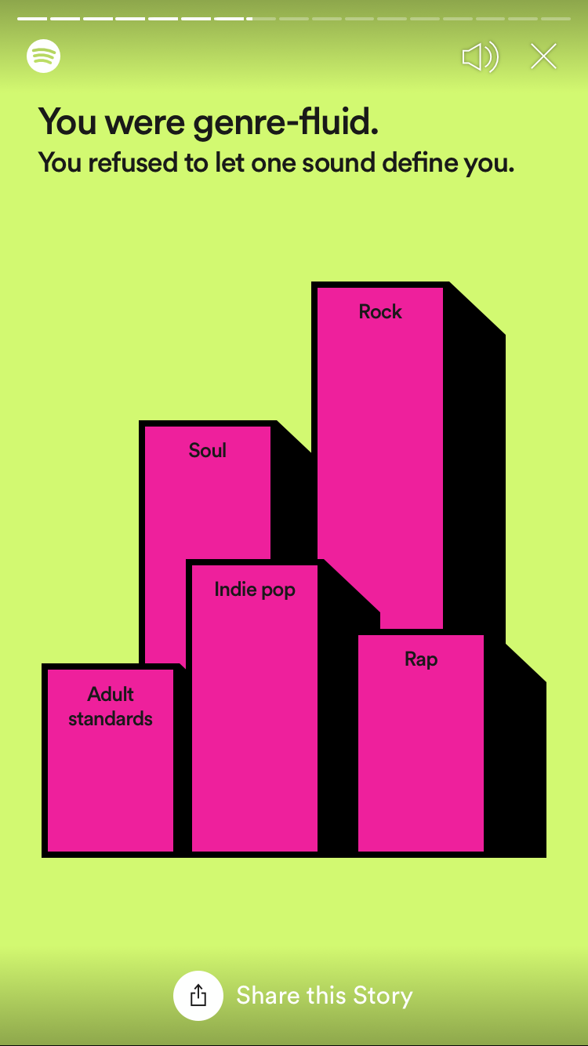
As you can see, my most listened to genres and the relationships which these genres have with my other top genres shed a very specific light on what kind of music consumer I am. Rock being my most listened to genre might not seem revealing, however, with Soul being second as well as Adult Standards being fifth— the exact type of rock and hybrid forms of rock I listen to can be deduced pragmatically.
My taste belongs to a group of people who might share many characteristics as me, namely my buying habits and my political beliefs. Conventionally, it is likely that if my specific taste profile was gathered in a group, we would likely get along well. However, Discover Weekly is characteristically “Black Boxed”, meaning that while the results of the collaborative filtering is reliant on a number of other consumers and their data, each individual user does not have access to those other similar consumers. Instead, they are only presented with their own interface. If these “Black Blocked” codes were no longer individualised and instead social, communities of taste profiles would then be able to interact with each other. My specific playlists could be shared and talked about with like-minded and conscious people. The infrastructure of Spotify, by virtue of its seeming objective and expansive methods, is isolating and limited in practice.
To further reinforce my idea that people with similar music tastes might get along well and have the same buying habits: as of January of 2019, Spotify has begun to profit off of selling taste profiles to marketing agencies. Spotify allows companies to specifically advertise to chosen taste profiles on Discover Weekly. Spotify users who do not pay for Premium accounts (about $10 USD per month), which is 118 million of the platform's 200 million active users, are now subject to advertisements by companies which pay to manipulate their aesthetics experiences by inserting their 30 to 90 second advertisements amidst their specific music listening tastes. If a company felt that my archetype of a consumer, and thus a person, is a potential consumer of their products, then they can target me by vehicle of Spotify categorizing me to a certain taste.
The result of this transaction is a powerful mechanism of influence. Since Discover Weekly can develop an understanding of its consumer insofar as it produces exactly the type of music they look for, then whatever else appears on this playlist naturally goes through a less critical lens. The consumer will inherently accept it by virtue of already trusting the personal playlist. The mode of curation which personalized music exists in on the platform is now coupled with other aesthetics (considering products can have aesthetic qualities) for not the sake of the consumer but instead the sake of the private interests who pay for it. This action is an obstruction of the inherent ethic which collaborative filtering presents itself to be, unbiased. In extrapolation, the ethic which seems to be inherent to the objective approach of collaborative filtering dissolves when it is intersected with private interests. If a private interest can have a conceptualisation of an identity of a group of people, i.e having access to a group of consumers with similar Discover Weekly playlists, then whatever the private interests want to impose on a susceptible and common audience can be done strictly via monetary means.
YouTube
Of all entertainment platforms, YouTube possesses the broadest use of media and because of this it possesses the most versatility of recommendations. Rather than conclusions, only the platform’s possibilities and unknown implications can be entertained. According to research, YouTube has an all encompassing approach to collaborative filtering recommendations. Regardless of the type of media, YouTube follows a two-network approach for videos. First the algorithm creates a candidate generation network which “takes the user’s activity history (eg. IDs of videos being watched, search history, and user-level demographics) and outputs a few hundred videos that might broadly be applicable to the user” and then introduces a ranking network which “takes a richer set of features for each video, and [scores] each item from the candidate generation network.” Here is a visual of this process:
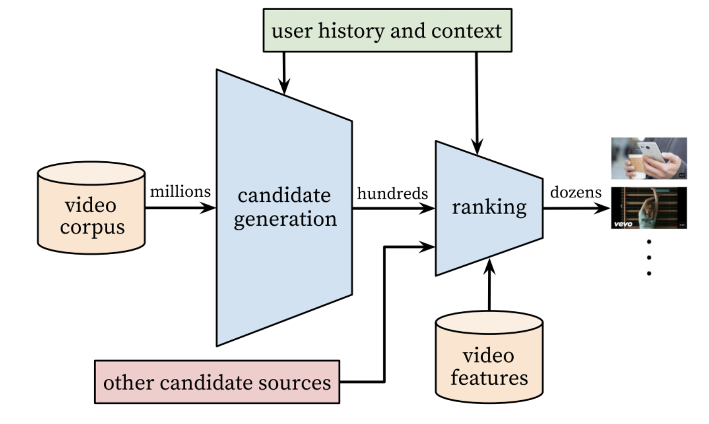
Essentially, the issue here is the lack of acute curation. Theoretically speaking, the amounts of certain kinds of media which society consumes is very broad. For example, when MTV was released in the 80s, the idea that one would sit down and watch hours upon hours of music videos suddenly became possible and in some situations normal. Nonetheless this occurrence was generally considered a modern perversion of consumption. This is the same for films when VCRs came out. Then, people did not have to go to the movie theatre to watch a movie, instead they could watch it from the convenience of their own home. When the advancement of technology produces a new infrastructure, an initial obsession occurs with its products and then a tapering off. What makes YouTube so special is that it is not confined to a certain genre of video. Any type of video genre can become the subject of consumption, and the autonomy which YouTube as a videographic infrastructure provides, only enhances the unlimited viewing of any said material. For example, if I begin watching fitness videos, my ‘user history and content’ would be entirely one type of video. If there is a large population of people just like myself who only watch one video, then the second filter, the ranking network, would only enforce my single interest. What begins to be created by this simple algorithm are circular consumption patterns which lack interest in other things. YouTube is very susceptible to create what is often called echo-chambers.
An echo-chamber is a metaphorical description of the situation in which beliefs and habits are incentivized and promoted by a consumer’s decisions to only watch certain types of media, especially media which reinforces one's political beliefs. YouTube heightens the mobility of all forms of biased consumption, especially the biased media which liberal and conservative legislation battles today in America. As early as 2006, YouTube as an echo-chamber started to appear under the public's criticism when it became evident that the U.S. presidential election was being highly impacted by the political echo-chambers which were occuring on the platform. Whether it be politics, blogging, or forms of art; the tastes of consumers when they are navigated on platforms, which appear to be unbiased, ought to have algorithms in place which test the tastes and question the enforced consumption ideologies of its consumers. This notion has been evidently necessary in the historical examples of MTV and VCR as well as our modern political environments as they relate to digital consumption. Collaborative filtering under simplistic models promote the echo-chambers of art and ideas.

TikTok
TikTok is currently the newest and foremost leading social media platform of societal engagement for generations X and Z. Originally created to be an expressive platform of short talent videos lasting up to 60 seconds; it was built to mirror the previous leading social media platform, Vine, a social media app also for short talent clips lasting up to 6 seconds. Today, TikTok has expanded its genres of videos to dancing, singing, comedy, politics, etc., all of which have the capability to vehicle powerful memetic culture semiotics. In this section I will touch on the memetic apparatus that TikTok has produced since its merger with Musical.ly and its infamous discriminatory recommendation guidelines.
When the platform opens, the consumer is immediately directed to a collaborative filtering based recommended video. Without pressing anything, new content begins playing at a perpetual loop, unless the consumer swipes down, a movement which plays a new video, or swipes right, a movement which views their own profile and subsequently plays their own videos. On the first page, the order in which the videos are displayed is not in chronological order or in any other predictable fashion. There is no background interface which videos play on; the entire phone screen is the video with a graphic of rising likes, comments, and views, increasing by the second.
The most common genre of video shown on TikTok is lip-syncing. From 2012 to 2018 Musical.ly was a social media platform on the app store used by kids from ages 12 to 16 and featured the possibility to use pre-saved lip-syncable audio recording for personal videos. The audio was typically a verse from a pop song on the Billboard Hot 100 or a dialogue from a notable TV show or movie. A (child) consumer could perform any sort of performative visual aesthetic to accompany the audio, contributing to the audio as meme. In late 2017, this app was bought by the parent company of TikTok, ByteDance, for 1 billion USD, consequently decimating Musical.ly and putting all of its features on TikTok.
On TikTok, once a post is shared the video can be memed by anyone, just like Musical.ly. Memed in this context is using the audio of another user’s video and then providing a different visual performative take on it. Sometimes the performance is an established dance which corresponds to the audio. Videos which use the same audio file are filtered onto a shared page, and the unification of memetic aesthetics and social play appears to exist. All consumer’s performative aesthetic takes on a song, dialogue, etc., is dialectically shared in one place. However, contrary to an emancipated sharing of performance which almost happens, on these pages there appears to be a certain type of user which continually appears to be featured at the top (most viewed) of the pages. At first glance, like Spotify, this aesthetic commonality that the most popular videos share appears to be the taste profile of the TikTok populus. Yet, even in societies’ most alienated and superficial essence, it is sometimes difficult to understand why young, attractive, almost always white, wealthy, and thus unrelatable accounts, appear as the top viewed and ranked videos on the platform, regardless of the genre of song or regional accent of the dialogue. This evident taste profile of the populus additionally does not make sense because the app is available to everyone. Thus it would make more sense if the regional accented dialogue audio, as an example, conformed to the regional cultures of the people in the overlapping videos. For example, a southern accent dialogue audio file page might have its top videos as people who aesthetically present themselves as being from the South, rather than this other common archetype. Consequent of this common archetype, it is hard for an alternative taste to develop on the app because its theoretical exposure would be continually overshadowed by the established communities of the common archetype, which is clearly enforced by TikTok’s navigating infrastructure.
Many of the ringleaders of these established communities, which also bear the celebrity genre ‘influencers’, live in Los Angeles together in ‘TikTok Houses’. One notable house is called ‘The Hype House’, a collection of 19+ teenages who rent out a mansion and collaborate on dancing and comedy videos together. TikTok displays a perpetual feed of videos which seem to be created by groups such as the Hype House. Young, attractive, affluent, and fit teenages, gyrating their hips and just barely not sexually embracing each other in each and every video that graces the filtered screen. As it turns out, this strange and uncomfortable default feed is on purpose. The existence of such a ruling class is due to the fact that TikTok promotes it.
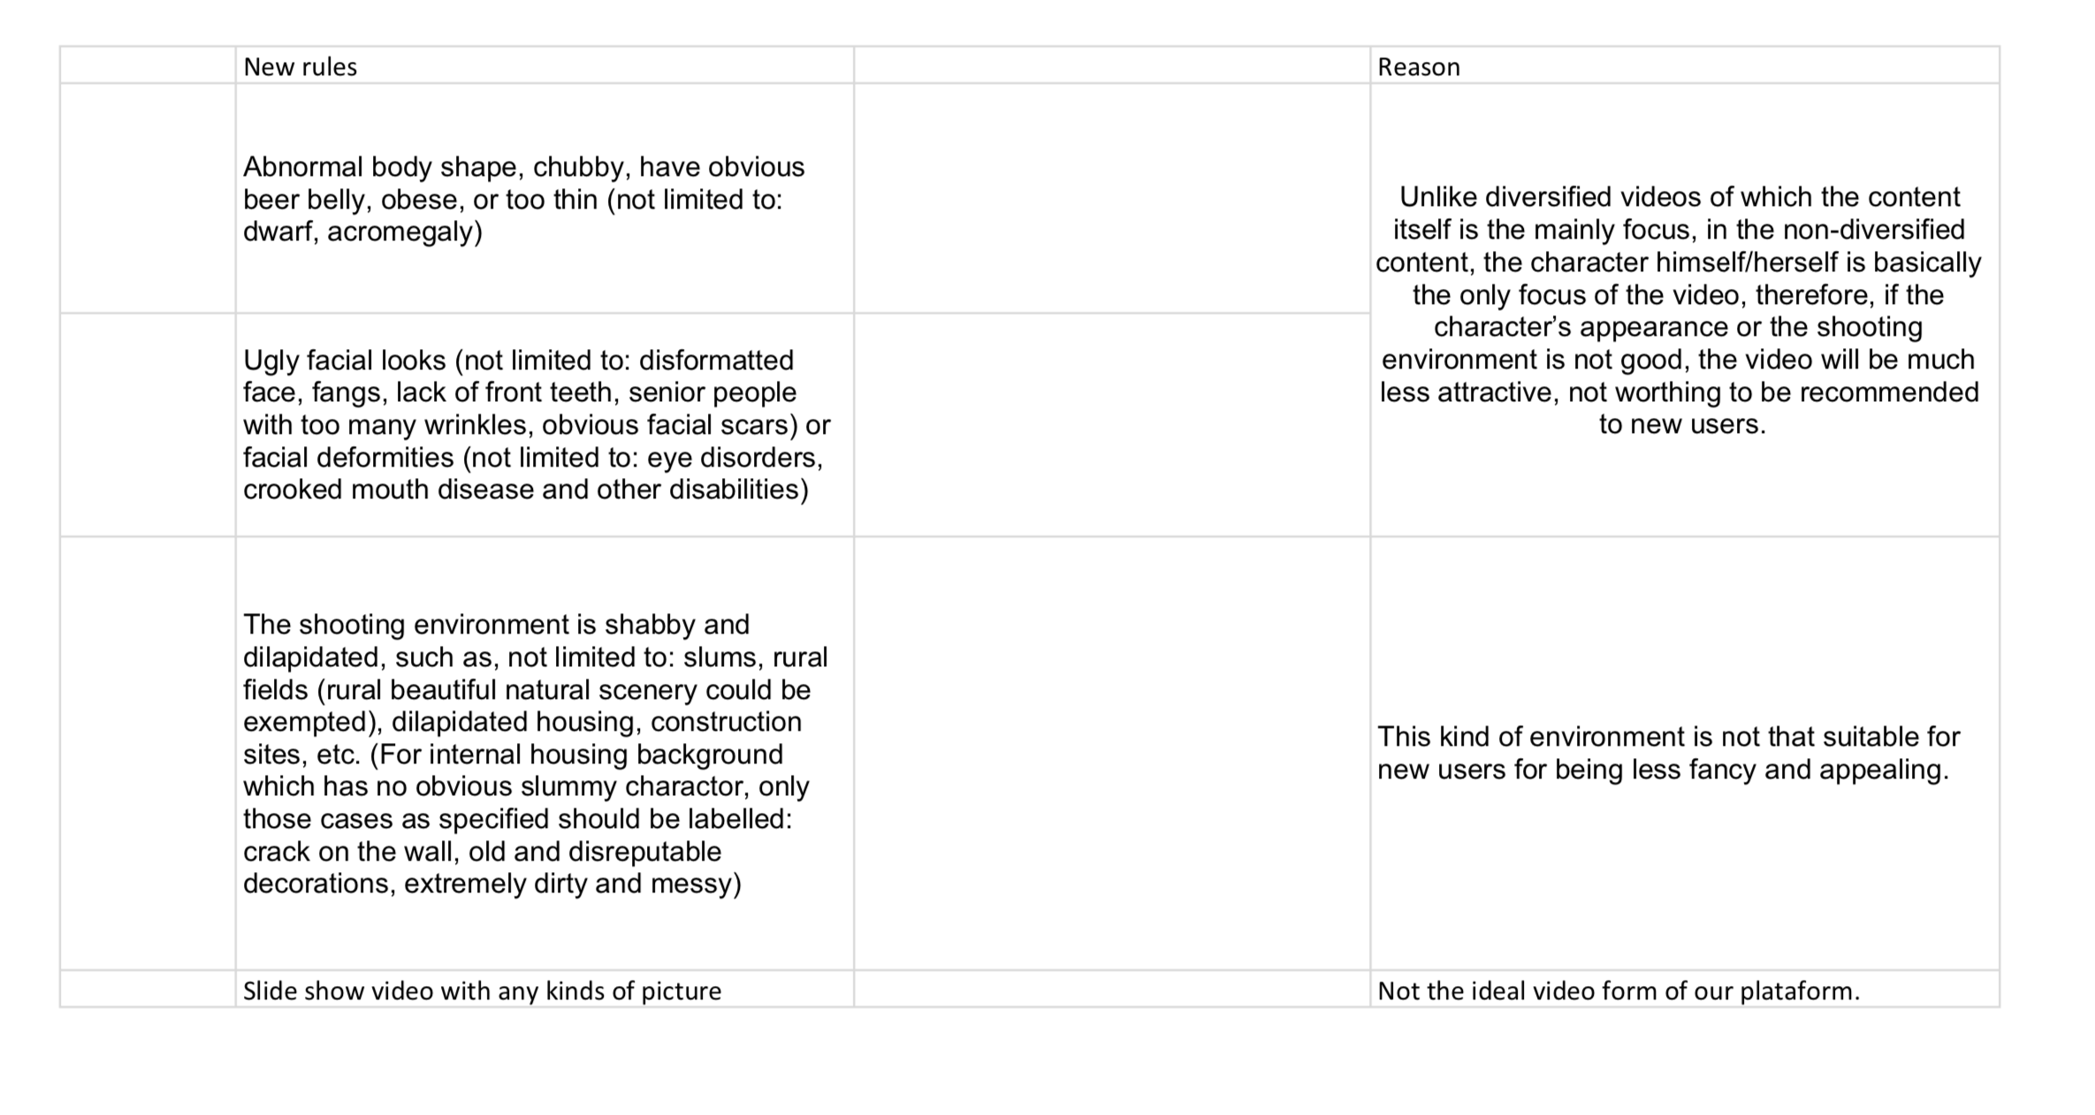
TikTok is a monetized social media platform which is owned by the CCP. Based on a combination of exposure, likes and followers, popular TikTok users get paid to post and raise the notoriety of the platform. With the rise of exposure comes a higher probability that the algorithm will view a popular account over a less popular account. While this does not seem very problematic, the videos which reach the app feed are filtered through a vicious and intentional filtering process. The guidelines of exposure vetting have been leaked by the adversarial news source, The Intercept, and widely distributed across the majority of globally popular news websites. Here is the exact leaked document that was sent to ByteDance moderators:

As it is seen, the New rules are the moderators instructions and the Reason on the right is the company's explanation for these values. Any bodies which do not conform to the narrowest qualification of western fitness, facial distinctions which are not normative or young-looking, not limited to “eye disorders”, are not allowed. The environment of the video must be of metropolitan society, unless the background is “beautiful natural scenery”. There can be no defects in the background such as cracked walls. Additionally, slide shows are prohibited as its format is not ideal for the video platform.
TikTok is the embodiment of the authoritative use which Netflix, Spotify and YouTube loomingly hint towards. While collaborative filtering can promote the objectification of human engagement, the private monetisation of isolated communities, and echo chambers; where these platforms do not completely reach, TikTok does. TikTok displays the bad blooded, bad intentioned possibilities of an AI-filtered aesthetic interaction platform.
- Conclusion: Abstract problems of progress
Collaborative filtering simulates an infinite access to the consumer’s taste. What would otherwise take time and experience for the consumer to discover is streamlined into a continuous stream of recommendations. These recommendations infinitely inform themselves of the nuanced and otherwise unaccounted information of the consumer. This cycle of information and the pleasure which is derived from it (by the consumer) forms a determinative culture of aesthetic discovery. No longer do social events or regional influences impact the consumer’s discovery. Instead, aesthetic platforms provide a descriptive and accessible viewpoint in which the consumer (in unison with all other consumers) can find favorable aesthetics. This seemingly infinite amount of material which is recommended simulates an all knowing recommender.
The problem with this simulation is two-fold. First, the consumer manufactures their sense to navigate and develop their aesthetic taste to the utility of the algorithm. In this sense, collaborative filtering can be considered an infrastructure. Consumers no longer rely on how they feel when developing their tastes, they rather look to the algorithm to tell them. French philosopher Jean Baudrillard believed that simulating a stable reality is important to the maintenance of power. The stable reality in this sense is the idea that an algorithm can know the consumer better than they know themselves. Baudrillard describes this notion in Simulacra and Simulation, “If one envisions the entire[ty] of any cycle of any act or event in a system where linear continuity and dialectical polarity no longer exist[s], in a field unhinged by simulation, all determination evaporates, every act is terminated at the end of the cycle having benefited everyone and having been scattered in all directions (Baudrillard, 16).” Aesthetic platforms provide a linear continuity and dialectical polarity for genres of media. On TikTok songs can be memed by dance, on Spotify all personal tastes in music can be condensed into curated playlists.
These infrastructures for experiencing aesthetics provide the entertainment industry with a productive and determinative scope of the progression of the aesthetic. Ergo, the art which is made today and the art which is recommended today is in direct conversation with what was made yesterday and what was liked yesterday. If this linear continuity were to break and the discovery of the aesthetic was not victim to the marketing tactics and algorithmic machine learning of the digital sphere, the art created and the art consumed would not just be different, but instead possibly completely and entirely foreign to generally accepted social tastes. The situation we are in has been historically called the Culture Industry. This situation infers that the aesthetics consumers are naturally inclined to enjoy do not correspond with the desires of the neoliberal economy. However consumers do not know this and the entertainment industry convinces them to unconsciously conform their desires to the desires which are productive to the industry.
For culture to economically compete at the level that it does, the recycling of the aesthetic must be deemed detrimental. Since the consumer is the sole driver of the industry, the consumer thus needs to be simulated to believe that the normative of culture consumption is a hyper-transitive continuity of taste. This maxim is the basis of the aesthetic algorithm. Insofar as collaborative filtering’s function is to introduce more content, the more content viewed by the consumer is the measure of the advancement of the algorithm. Collaborative filtering pressures consumers towards finding newness as opposed to revisiting and contemplating the old. The consumer needs to prefer brevity over intensity because their consumption is an end to an economic system and not a means to themself.
However, understanding collaborative filtering to be beneficial to the consumer logically makes sense. Countless amounts of research and works of philosophy infer that personal identity has many aesthetic dimensions— in that the self is inevitably variable and always changing. If the aesthetics a person consumes corresponds with their personal identity then when their personal identity changes so do their consumption habits. So, using Baudrillard’s words, the “linear continuity” of taste must actually be an unsimulated aspect of aesthetic engagement. While algorithms do provide a very coherent and stabilized semblance of identity, more stable than we might consider ourselves to be, it does not particularly conflict with the natural progressions of consumer tastes.
In response to this rebuttal, it is worth confessing that any criticism of popular culture can seem like a form of asceticism. Be that as it may, the argument for and against collaborative filtering is actually an argument of whether or not the reality of culture without these systems is more or less conducive to the aesthetic dimensions of society. The algorithm based entertainment industry is built upon the idea that there is no inherent structure to aesthetic taste and because this is so, in order to have a predictable and coherent production of art, it is in the best interest of the industry to reinforce a steady and gradually changing societal taste, as such a consumer is reliable. This research, being on the other end of the argument, argues that if there is no inherent structure to aesthetic taste then it is in the best interest of the consumer to be susceptible to any sort of change of taste for it is always a reflection and growth of the self. The hegemony of entertainment has the consumer entertained by a simulated structure, not something innate within themself.
In order to deliver a message effectively to the populace, the entertainment industry has created the spectacle in order to communicate social and political notions. French theorist, filmmaker, and founding member of Situationist International, Guy Debord re-conceptualized the ‘spectacle’ in his 1967 work, La société du spectacle. Debord defined the spectacle as the social relation consumers have with the aesthetics of entertainment. He concluded that popular entertainment’s production had formed an autonomous agency and denied the consumer involvement in its formulation. In other words, entertainment had become a streamlined production which created artworks without concern of society's interest in them. Rather than social involvement with these streamlined aesthetics, Debord realized that modern consumers had become passive to its production and identified its ‘manufacture of alienation (I-32)’ as genuine social activity.
The question arises, “How is the algorithm as spectacle effective?” I argue that it is because of the algorithm's decentralization of power. Michel Foucault’s historical analysis of the Middle Ages provides an example of power decentralization. The institutions of the Middle Ages, the monarchy and its subservient power apparatuses, found its power in decentralizing its government. Rather than having an economic direction or moral objective like an ideology, monarchies would instead rise to power on the basis of previous institutions. Monarchies would similarly emulate their predecessors but also publicly oppose them in multiple forms, directly and indirectly. Instead of simply expressing the monarchy’s platform, per say, they would instead complicate and tangle the public understanding of its power such as joining new alliances to redistributing the positions of arms and trade approaches. While the established power still remained precedent, minor changes and strong rhetoric provided the public with an understanding that its approach to power and order was invariably stable.
Is this not the actions of the platforms of aesthetic distribution? Each of the aesthetic platforms (Spotify, Netflix, Youtube and TikTok) which were analysed in this research are organizational infrastructure technologies which belong to a succession of countless digital predecessors. The introduction and the decimation of these platforms, although they are built for the public, are completely in the hands of private interests and industry. The autonomous maneuverability displayed in the unsocial changes by the aesthetic platforms analysed, such as the selling of taste-profiles on Spotify and Netflix’s A/B algorithms for cover image preferences, overtly highlight a societal acceptance of being a cog in a machine. All of these functions are imitations of previous platforms (iTunes and Blockbuster for the cases of Spotify and Netflix), and each of those imitations are imitations themselves dating all the way back to the natural social relations of communal aesthetic sharing and discovery. Changing the means of communication (isolating the consumer), the physicality of aesthetic experience (continuously updating and introducing platforms), releasing technologies to access culture in unexplainable ways (TikTok’s feed), to the general public, is blindly accepted. Further, when these algorithms produce ineffective and unethical results, there is no blame placed on a person or the institution as it is considered just a ‘stutter’ in the progress of better technology. This very autonomy of the algorithm only reinforces its spectacle. How can we be forensic agents when the apparatus is inhuman? There is no blame hence there is no democratic and social disruption to the platforms in control.
The both un-preventing response and unsocial (none) input which consumers accept in their reliant interaction with algorithmic advancements considers the notion that we are living in a technological positive society. German Philosopher Herbert Marcuse conceptualized technological positivism as the ideology which believes that the advance of technology is innately good. Our global tech industry undoubtedly subscribes to technological positivism and this ethic is only reinforced by the consumers which are passive to its occurrence. However, as much as this self-destructive passivity appears to enhance private industries, the efficient filtering of the mass production of aesthetics to the consumer, from an economic standpoint, is not as advantageous as it might seem.
At the beginning of this section I wrote that the problem with collaborative filterings simulation is two-fold. The second problem of the simulation is the economic inefficiency of these oppressive algorithms. When the consumer is left to their social relations to discover music, they discover and change their taste in relation to the discovery and changing of their personal identity: passionately, slowly, and in-depth. Today, when a band comes to town, and a college student has an exam the next day, and the ticket is $30, the college consumer is deferred in three different ways: First, the concert will conflict with their exam, second, the ticket is expensive, and third, the interest they have in this band is merely an addition to the entire broad taste they have for a certain genre. Hence the band also is a cog in the machine; a cog in the machine of the vast aesthetic library and taste of the young consumer. Had the college student pondered on the artist, slowly, listened to their music, repeatedly, bought albums, t-shirts, talked to friends about it (considering they found this music socially), and made friends and connections over the music: the price of the ticket and the importance of the exam the next day would not matter to the young consumer because the music would matter more. They would go to the concert for $30 as they have already spent $60 by being a fan of the band. If the entertainment industry could begin to understand how much society cares about aesthetics and how it is inevitably related to personal identity, maybe the corporations in the culture industry wouldn't smother the populace with a material output which suffocates it. This output is the very reason the industry has to rely on algorithms: to organize it.
German Psychologist Eric Fromm wrote in Escape from Freedom “that there is only one meaning of life: the act of living itself (263).” In the beginning sections of this research, the act of living has been described through the lens of a perpetual and never ending engagement with the aesthetic. Humans as consumers in the modern age always identify the aesthetic in relation to the means of production. What is solitude for us today is different from the solitude of the past and the future. The aesthetic and technology relate to each other, and sometimes they overlap. Infrastructure studies as an approach to this analysis shows us how our inherent attraction and curiosity to aesthetics can be manipulated for the efficiency of development. This manipulation has largely become what Marx called the manufacturing of the senses. This process of adapting ourselves to the means of production has allowed technologies such as collaborative filtering to exist without our analysis. In the middle sections of this research, close analysis was done on four different platforms which utilize collaborative filtering in order to understand consumers’ taste in order to distribute more art. This research has concluded these actions to be alienating and unsocial developments to the social relations of living. Today, life in the aesthetic realm exists as an individual and personal experience. This relation we have to the aesthetic still induces the philosophical actions of play and dialectical thinking. However, these actions should be done with our communities, with our friends. Insofar as collaborative filtering hinders our engagement with others while utilizing the data of us and others, we become less reliant to live together in society. In a world where nobody is an essential relation and personal identities are not enhanced by the ideas of others, both the consumer and the producer lose in each of their own searches for enjoyment and capital. If Eric Fromm’s conclusion of life is true, then the acts of living must not be constrained. This research has outlined the conveniences of collaborative filtering to be constraining to social life because it has formed its own apparatuses, such as the spectacle, which conflict with the act of living itself.
I want to finish this research with a 2015 art exhibit by Danilo Correale called “The Missing Hour: Rhythms and Algorithms”. In the exhibit there was an artwork called Mr. Bojangles. The artwork was a series of books with a single page ripped out next to it. The first book is Capital: Volume 1 by Karl Marx and the next book is Property is Theft! A Pierre-Joseph Proudhon reader. Each book in the succession is the highest recommended book by Amazon once the artist ordered the previous book. Having all of the books lined up, each with a random page ripped out as an excerpt, the artwork displays an incoherent magnum opus of Marxist political theory. It is unorganised, yet structured by its pattern, and it will be useful to no one who tries to understand it. However, looking at the artwork in totality, the viewer, the consumer, might begin to understand the problem of what is going on.

The first modern philosophical formulation of aesthetics invoking ‘the beautiful and ‘the sublime’ is in Kant’s Analytic of the Beautiful, in the Third Critique
Society of the Spectacle, Debord (6)
Walden; or, Life in the Woods, Thoreau
Semiotics is the study of signs and symbols, their uses and interpretations. It was popularised in french philosopher Roland Barthes’ study of the image in photography in Camera Lucida.
Hans-George Gadamer’s aesthetic theory extrapolates on this discussion in his essay, The Relevance of Beauty
Technological Positivism: the idea that the advancement of technology is inherently good, a term coined by Herbert Maruse in his work One-Dimensional Man.
USD: $9.99 (Spotify, Apple Music) to $12.99 (Netflix)
"Lokomotive Der Gefühle". Der Spiegel (German). 26 December 1994. Ein Kurzfilm wirkte besonders nachhaltig, ja er erzeugte Furcht, Schrecken, sogar Panik.
The Aesthetic Dimension, Marucse
The Tempest, Shakespear
The Aesthetic Dimension, Marcuse
Translation: The Arrival of a Train at La Ciotat Station (1895)
For more on Reflective Judgement, read Aesthetic Theory, Adorno
Pet Sounds, The Beach Boys (1966)
For more information: Recollections, the Detroit Years: The Motown Sound by the People who Made it., Ryan
2019 PG&E California wildfires
Also known as: ‘code’
Koza, John R.; Bennett, Forrest H.; Andre, David; Keane, Martin A. (1996). Automated Design of Both the Topology and Sizing of Analog Electrical Circuits Using Genetic Programming. Artificial Intelligence in Design '96. Springer, Dordrecht. pp. 151–170
Journal of Information Policy Vol. 9 (2019), pp. 307-335 (29 pages)
G. Linden; B. Smith; J. York.; (January / February 2003). IEEE Internet Computing. Journal., pp. 76-79
James Bennett; Stan Lanning (August 12, 2007). "The Netflix Prize" (PDF). Proceedings of KDD Cup and Workshop 2007. Archived from the original (PDF) on September 27, 2007.
Chapter 1, Algorithmic Privacy; The Ethical Algorithm, M. Kearns; A. Roth. eBook
This relative scale could work on platforms, such as Spotify with song play counts and, radio dislikes
https://qz.com/571007/the-magic-that-makes-spotifys-discover-weekly-playlists-so-damn-good/
https://netflixtechblog.com/artwork-personalization-c589f074ad76
https://www.vox.com/the-goods/2019/1/11/18178701/spotify-discover-weekly-brand-playlists-personalization
https://www.nytimes.com/2006/08/20/weekinreview/20lizza.html?ex1313726400&ena605fabfcb81eebf&ei5088&partnerrssnyt&emcrss
https://www.nytimes.com/2020/01/03/style/hype-house-los-angeles-tik-tok.html
The Chinese Government; Communist Party of China
There is also a Mandarin-Chinese translation to these guidelines.
The Ethical Algorithm, M. Kearns; A. Roth
https://www.businessinsider.com/how-spotify-taste-profiles-work-2015-9
https://techcrunch.com/2019/01/07/spotify-will-let-now-brands-sponsor-its-discover-weekly-weekly-playlist/
https://towardsdatascience.com/how-youtube-recommends-videos-b6e003a5ab2f
Vine has since gone bankrupt and has left the app market as of 2016.
The idea of a meme: a cultural aesthetic which is repeated many times, however, each repetition consists of minor differences, still maintaining the essential qualifying identity of the original.
Play in Gadamer’s understanding of the term
Also see China’s similairly mechanistic guidelines for the surveillance of Muslim Uighurs: https://www.icij.org/investigations/china-cables/exposed-chinas-operating-manuals-for-mass-internment-and-arrest-by-algorithm/
The History of Sexuality, Foucault
Namely, consumer data.
Referencing Adorno’s “Culture Industry”
Netflix’s A/B algorithm is a good example of this
Referring to the idea that the self can be interacted with in many aesthetic forms.
One Dimensional Man, Marcuse
John Locke considered forensic agency to be a fundamental aspect of politics, meaning that people are able to give and take blame.
The literature of the first and second generations of the Frankfurt School largely studies this.
Frankfurt School philosophy Walter Benjamin furthered this notion in his essay, Surrealism
These ideas of infrastructure were borrowed and inspired by readings and a skype conversation with Barnard College Anthropology professor, Brian Larkin.
Karl Marx’s Economic and Philosophic Manuscripts of 1844; Progress Publishers, Moscow 1959; Translated: by Martin Milligan. Marxist.org.
This example consumer is not from The Ethical Algorithm.
There are many other statistics which are presented to consumers.
https://www.musicbusinessworldwide.com/spotify-acquired-echo-nest-just-e50m/
For context, Instagram was bought by Facebook for 1 billion USD in 2012.
https://www.businessinsider.com/social-video-app-musically-acquired-for-up-to-1-billion-2017-11
These two genres of performance are very common.
https://theintercept.com/2020/03/16/tiktok-app-moderators-users-discrimination/
Simulacra and Simulation, Baudrillard
Escape from Freedom, Fromm

